EXPLORATORY DATA ANALYSIS (EDA)
  - Outreach & Applicant Dataset

1. Introduction
This report analyzes the cleaned Outreach and Applicant datasets to identify important trends, behavioral patterns, and anomalies in student communication and engagement. The purpose of this analysis is to turn raw activity logs into insights that can guide strategic decisions for enhancing outreach effectiveness, connection rates, and applicant conversion results. The findings are supported by tables, charts, and interpretive summaries that clarify why each pattern is significant and how it can inform operational changes.

2. Key Insights Identified Through EDA

Insight 1: Most Outreach Attempts Do Not Lead to Successful Engagement, Indicating Major Barriers in Reachability and Applicant Readiness
The outreach data shows that most attempts do not lead to meaningful engagement. The largest group, “Not connected,” has 24,498 instances. This category makes up nearly two-thirds of all outreach interactions. When we add “Wrong number” (2,520) and “Disconnected” (1,588), it is clear that a significant portion of the contact list is either unreachable or has incorrect phone numbers. This trend limits the effectiveness of outreach efforts and highlights significant issues with data quality or the timing of communication.
At the same time, categories that show progress or successful conversion, such as “Completed application” (813), “Ready to pay the deposit” (344), and “Already paid the deposit” (77), are relatively small compared to the total data set. This big difference shows that while there is a group of engaged and motivated students, they are greatly outnumbered by those who are unreachable or choose not to engage.
Overall, this insight highlights a serious operational challenge. The current outreach process faces significant barriers from low reachability and high data inaccuracy, which limits the team's ability to influence the enrollment pipeline. Improving phone number validity, adjusting outreach timing, and refining segmentation could greatly enhance connection and conversion rates.
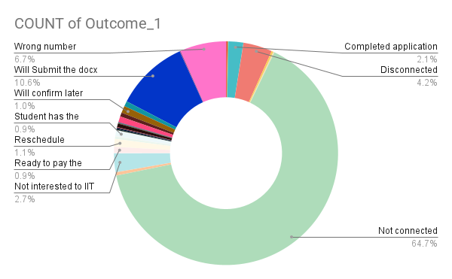

Insight 2: Outreach Success Is Highly Polarized, With Only 24% of Attempts Resulting in a Successful Connection
The second-level outcome (Outcome_2) shows a clear divide between successful and unsuccessful outreach attempts. Out of 37,881 total attempts, only 8,957 (24%) resulted in a successful connection, while a much larger portion, 28,924 attempts (76%), were categorized as Not Connected. This "Not Connected" group includes several unsuccessful outcomes, such as wrong number, disconnected, voicemail, and attempts where the call did not connect.
This imbalance suggests that most outreach efforts never reach the student, highlighting a system issue with reachability. When three out of every four calls do not connect, it limits the team's ability to influence enrollment behavior, provide guidance, or help students move forward in the application process.
The insight indicates that data quality, call timing, and segmentation strategies may need improvement, as a relatively small number of successful connections face the challenge of potential conversion. Enhancing reachability, even slightly, could significantly improve overall campaign performance.
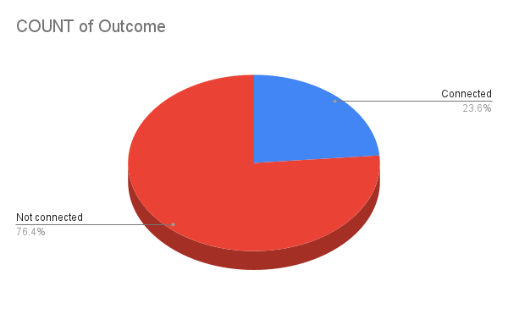

Insight 3: Applicant Pool Is Highly Concentrated in a Few Countries, With Significant Data Inconsistencies in Country Labels
The applicant pool is focused in a small number of countries. India has 5,675 applicants and Ghana has 1,928, making up the bulk of the dataset. Nigeria follows with 1,575 applicants, and Bangladesh has 295. These four countries account for most applications, showing strong regional demand and distinct geographic recruitment areas.
However, the country field has many inconsistencies and misspellings that disrupt counts and hide the true volume. For example, there are variations like “Brasil” and “Brazil,” “columbia” and “Colombia,” “Indinesia” and “Indonesia,” as well as multiple forms of Côte d'Ivoire. Moreover, some entries are not countries at all. Examples include “Finance,” “personal reason,” and “Not attending Illinois Tech…,” which shows that the field was not used consistently during data entry.
This mix of high geographic concentration and significant country-label issues makes accurate regional analysis difficult. Fixing the spellings and removing non-country entries would provide a clearer and more useful view of the global applicant distribution.
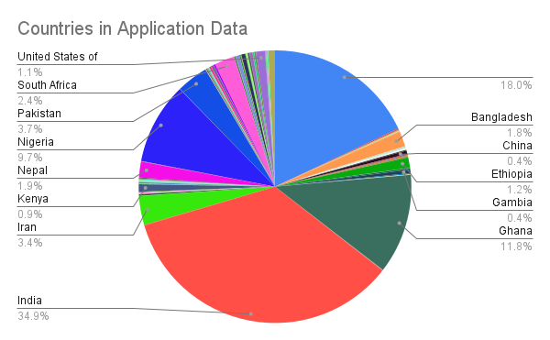

Insight 4: Country Field Shows Major Data Quality Gaps, Limiting Reliable Geographic Analysis
The Country column has serious data quality problems that weaken the trustworthiness of geographic insights. Out of all records, only 13,347 entries have valid country names. There are 2,928 entries that are completely blank, and another 618 entries include email addresses instead of country names. This means that nearly one-quarter of the dataset, about 4,000 records, has unusable or incorrect country information.
These gaps greatly hinder the ability to examine applicant trends by region, spot high-performing markets, or effectively customize outreach strategies. The presence of emails and blank values also indicates issues with data capture upstream. This suggests that clearer form structures or validation rules might be necessary. Fixing this problem is crucial to restore confidence in geographic reporting and to support more focused, data-driven outreach decisions.
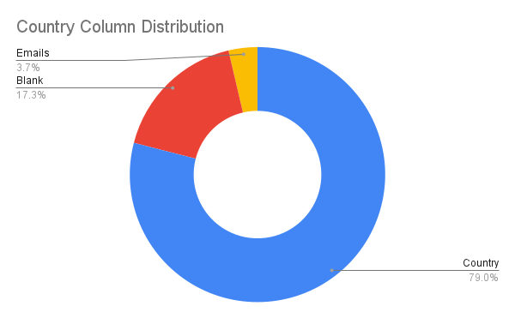

Insight 5: High Call Connectivity Does Not Translate Into IIT Admissions
Although the outreach team successfully connected with 8,957 students, only 20 students show confirmed admission or committed arrival to IIT in the remark records. This means that less than 0.25% of students reached through successful calls ultimately move forward with IIT enrollment.
The large gap between high connection volume and very low conversion to admission indicates that the issue is not the team’s ability to reach students but rather external and downstream factors, such as competing university offers, visa denials, financial barriers, missing documents, or lack of timely institutional response. The remark dataset shows hundreds of cases where students either chose other universities, faced document challenges, or were waiting for support. This suggests that conversion loss happens after the initial call, not during it.
This insight highlights a critical opportunity. Improving follow-up processes, documentation support, scholarship clarity, and response times could significantly influence the yield rate, as call success alone is not converting into admissions.
